**Product Acquiring System**

Software Requirements Specification

1.0

10-Sep-2022

Sanjay Raj Goud Bindi

Abhishek Dharamkar Ramesh

Yashaswi Nagamalla

Yoga Narasimha Reddy Peddireddy

Sravan Suddakanti

Submitted in partial fulfillment

Of the requirements of

CSIS 44-691 Graduate Directed Project 1

**Revision History**

|  |  |  |  |
| --- | --- | --- | --- |
| **Date** | **Description** | **Author** | **Comments** |
| 09/10/2022 | Initial draft | Sanjay Bindi |  |
| 09/18/2022 | 2.0 | YogaNarasimhaReddy Peddireddy | Added chapter 2 content and attached ER diagram in chapter 4 |
| 09/23/2022 | 3.0 | Sravan Suddakanti | Added chapter 3, reviewed ER diagram and discussed regarding GUI |
| 09/23/2022 | 3.1 | YogaNarasimhaReddy Peddireddy | Updated the data flow diagram |

# **Document Approval**

The following Software Requirements Specification has been accepted and approved by the following:

|  |  |  |  |
| --- | --- | --- | --- |
| **Signature** | **Printed Name** | **Title** | **Date** |
|  |  |  |  |
|  |  |  |  |

**Table of Contents**

**Table of Contents Page Number**

1. Introduction

1.1.Purpose

1.2.Scope

1.3.Definitions, Acronyms, and Abbreviations

1.4.References

1.5.Overview

2. General Description

2.1.Product Perspective

2.2.Product Functions

2.3.General Constraints

2.4.Assumptions and Dependencies

3. Specific Requirements

3.1.External Interface Requirements

3.1.1.User Interfaces

3.1.2.Hardware Interfaces

3.1.3.Software Interfaces

3.1.4.Communications Interface

3.2. Functional Requirements

3.3. Use Cases

3.4. Class/Objects

3.5. Non-Functional Requirements

3.5.1. Performance

3.5.2. Reliability

3.5.3. Availability

3.5.4. Security

3.5.5. Portability

3.6. Inverse Requirements

3.7. Design Constraints

3.8. Logical Database Requirements

3.9. Other Requirements

3.10. Prototypes (for complete project)

3.11. Use Case Diagrams

4. Design

4.1. ER diagram

4.2. GUI

5. Analysis Models

5.1. Data Flow Diagram

5.2. Sequence Diagram

# **1. Introduction**

To develop a system where the buyers and sellers meet.

**1.1**  **Purpose**

The main objective of this project is to provide a platform to build a solid communication between buyer and supplier. The buyers can put their requirements, specifications and quantity of demand for the particular products. The Seller on the other hand gets notifications when such a request is posted. Now the seller can respond to that request with his quote, stating the quantity that he can supply , and the price at which he can offer the product to the buyer. Later multiple such quotes by multiple sellers on the platform are sent to the buyers , where they can choose the best possible quote and perform the trade.

**1.2 Scope**

The Product acquiring system is responsible for maintaining a relationship between buyer and seller to make a purchase where the seller adds a product with a certain amount of quantity which he can sell. Now, PAS notifies the buyer when such is posted and helps buyers to purchase the required quantity at given cost. PAS plays a crucial role when there are multiple sellers selling the same product as it helps buyers to make a purchase according to their requirements.

**2. General Description**

Product acquiring system(PAS) is designed to help the buyers to find the sellers who will supply the products at the best price and fulfill the buyers requirements.

**2.1.Product Perspective**

A buyer can request things through the PAS, receive quotes from suppliers, and choose the best offer out of those offers. However, the seller might claim the customer the quoted prices and try to close as many deals as possible while earning the highest profit.

**2.2.Product Functions**

Themain functions of PAS are

* New buyers and suppliers can register using the register page
* To enable Buyer to search for the products and request quotes from the suppliers
* Supplier can claim the best deal which they can fulfill
* To enable buyer make payment to seller for the fulfilled deals
* To Track the Order status that the buyer has placed and the shipping status

**2.3.General Constraints**

In discussions, yet to decide.

**2.4.Assumptions and Dependencies**

* Each order has one and only one payment
* Buyer has at least one warehouse
* Supplier has at least one warehouse
* Orders are shipped through third party or buy supplier itself

**3. Specific Requirements**

**3.1** **External Interface Requirements**

We might need real-time buyers and sellers data.

**3.1.1** **User Interfaces**

1. Login module for both buyers and sellers

2. Search results view for products sold by sellers.

3. Requesting product quotations.

4. Claiming and payment page.

5. Shipping Address page

**3.1.2** **Hardware Interfaces**

In discussions, yet to decide.

**3.1** .3 **Software Interfaces**

In discussions, yet to decide.

**3.1.4** **Communications Interface**

In discussions, yet to decide.

**3.2**  **Functional Requirements**

**Buyer**

* Buyer registration for buying the products. (Login Page)
* Creating a UI for buyers where searching products takes place.
* Searching page for the product based on category.
* Filtering the products based on requirements.
* Quotation page for orders.
* Payment page for buyers.
* Acknowledgment page and shipping address page.
* Order history

**Seller**

* Seller registration for selling the products.
* Seller claim page to accept the buyer's request.
* Order tracking page
* Order history

**4. Design**

**4.1. ER diagram**

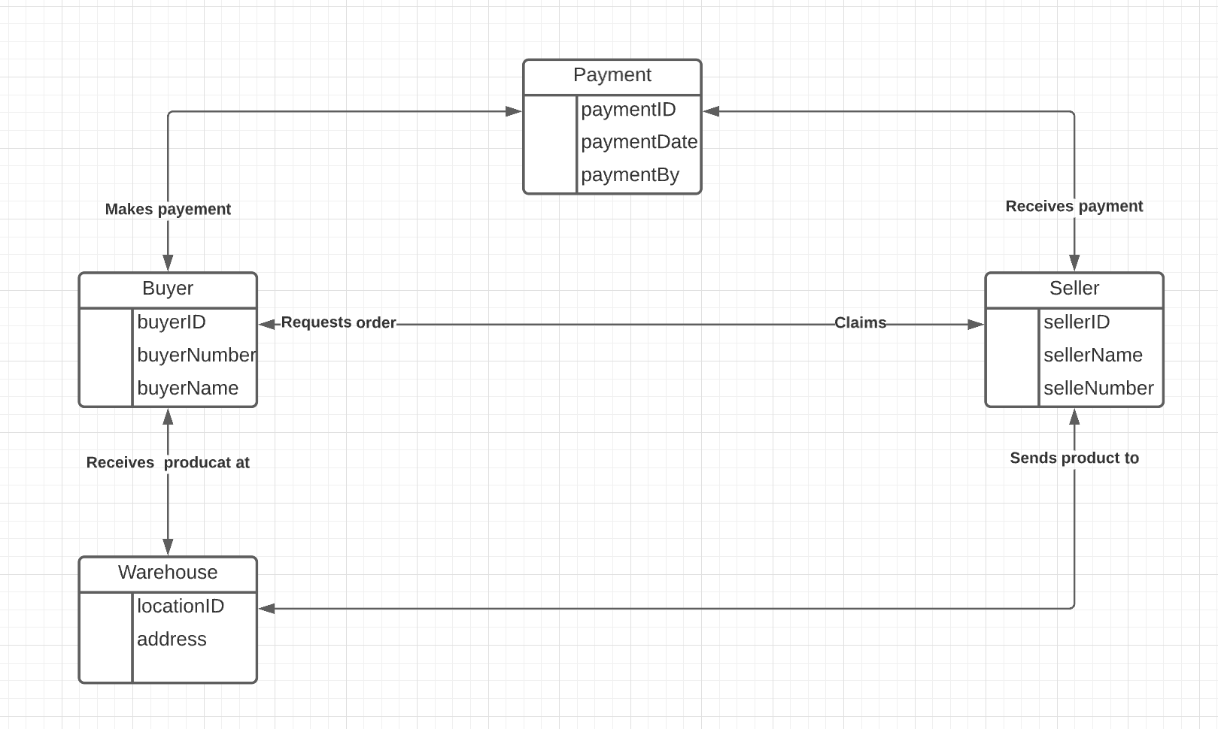

**4.2. GUI**

We are working on a graphical user interface, and we will be completing it by the end of this week.

**5 Analysis Models**

**5.1 Data Flow Diagram**

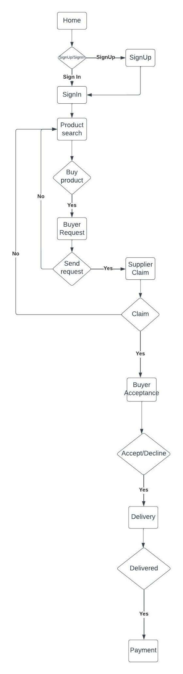

**5.2. Sequence Diagram**

